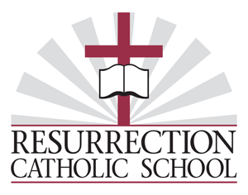
18th ANNUAL GOLF OUTING
TUESDAY, SEPTEMBER 12, 2023
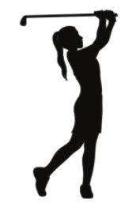
MEADIA HEIGHTS GOLF CLUB
402 Golf Road
Lancaster, Pa. 17602

Shotgun Start – 12:30 PM
4-Person Scramble - Open to Men and Women
RAIN OR SHINE

Registration begins at 10:30 AM
Hot Dog Lunch & Beer
Golf Contests and raffles
Barbecue buffet following golf.

$100 per golfer
Early bird registration: $85/golfer if registration and payment is received on or before July 7th.

Deadline for Registration: September 1st
Register and pay by August 1st for a chance to win a $50 GIFT CARD

GOLFER(S)
PLAYER #1 PLAYER #2
ADDRESS ADDRESS
CITY CITY
PHONE PHONE
EMAIL EMAIL

PLAYER #3 PLAYER #4
ADDRESS ADDRESS
CITY CITY
PHONE PHONE
EMAIL EMAIL

NOTE: If you are a single or twosome, we will pair you up.

Non-golfers may join us for dinner for $30. $__________ for _______ meals

____ I cannot play but would like to make a donation of $________

Checks payable to: "Resurrection Catholic School."

Mail to: Resurrection Catholic School
ATTN: KRISTY LEGENSTEIN
521 East Orange Street
Lancaster, PA 17602

Resurrection Catholic School Golf Outing
Meadia Heights Golf Club, September 12, 2023

Scramble format – The four-person scramble features teams of four players competing against one another. In this format, each team's players hit from the tee box, then the team members choose the best of the four shots for the next shot. All team members then play the second shot from that location, and again choose the best shot. Play continues in this manner until the hole is completed. The team then records its score and maintains that format for all 18 holes.

Rules for the scramble:

- Men - 62 years of age and older may play from the GOLD tees (except on hole 18 if you desire entry into the hole-in-one contest).
- Men - 61 years of age and younger play from the WHITE tees.
- Women - play from the Gold tees.
- No minimum drive per group.
- Double bogey limit on all holes.
- Place one club length (left or right) but no closer to the hole, from tee to green. The ball cannot be moved from the rough to the fairway. The ball cannot be moved out of the sand. All holes must be holed out.
Golf course etiquette helps everyone, so please try to keep play moving.

Scoring

- Turn score cards into pro shop after completion of play.
- Each player of the winning foursome will receive a $100 gift certificate for the Meadia Heights Pro Shop.
- In the case of a tie, winner will be determined by a random drawing.
- Second flight winners receive a $25 gift certificate for the Meadia Heights Pro Shop.

Attire

Gentlemen are to wear collared shirts or mock neck at all times. Crew neck, tee shirts, tank tops, or undershirts are inappropriate. Gentlemen are encouraged to wear belts and must have their shirts tucked at all times. Bermuda shorts, walking shorts, and golf/tennis attire are permissible. Jeans, cutoffs, athletic shorts, sweatpants, cargo shorts/pants, or any clothing that is worn, torn, ripped, or with holes is unacceptable. Hats, if worn, must have the brim facing forward.

Women with sleeveless tops must have a collar. Sleeved tops may be collarless but fashioned to appropriate apparel sold in pro shops/golf stores. The inseam of shorts must be 5” in length. Skorts, Capri, and all pants are acceptable if they are not denim.

THANK YOU for supporting Resurrection Catholic School and for being part of our day.

